PRODUCT BULLETIN
MODEL SST SELF PRIMER

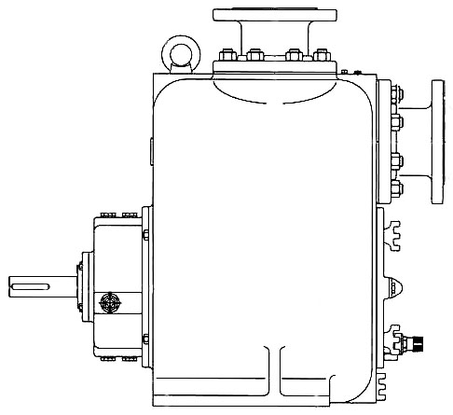
Material Specifications
PRODUCT BULLETINMUNICIPALCOMMERCIALINDUSTRIAL
MODEL SST SELF PRIMERLift Station, Sewage, Heavy Solids,Jobsite De-watering, MobilePulp & Paper, Steel Mill, Feed Lot,
PRONTO-PRIMEMobileManufacturing, Rendering Plant
Bulletin 490SST
Edition 1

Since 1935, American-Marsh has manufactured high quality and durable self -primer pumps. These products incorporate features that you have asked for. Oil lubricated bearings, oil lubricated mechanical seal and a large cover plate for inspection and service of the impeller, mechanical seal, wear plate and suction check valve. All models feature completely removable rotating assemblies that allow for quick replacement and inspection.

CONSTRUCTION | PART
CONSTRUCTION | VOLUTE | IMPELLER | WEAR PLATE | SHAFT | MECHANICAL SEAL
Ductile Iron Fitted | Cast Iron | Ductile Iron | Ductile Iron | 420 SS | Tungsten/Tungsten/Viton
Novolloy Fitted | Cast Iron | Novolloy | Novolloy | 420 SS | Tungsten/Tungsten/Viton
Bronze Fitted | Cast Iron | Bronze | Bronze | 420 SS | Tungsten/Tungsten/Viton
316 SS Fitted | Cast Iron | 316 SS | 316 SS | 17-4 PH SS | Tungsten/Tungsten/Viton
Cd₄MCu Fitted | Cast Iron | Cd₄MCu | Cd₄MCu | 17-4 PH SS | Tungsten/Tungsten/Viton
All Novolloy | Novolloy | Novolloy | Novolloy | 420 SS | Tungsten/Tungsten/Viton
All Bronze | Bronze | Bronze | Bronze | 17-4 PH SS | Tungsten/Tungsten/Viton
All 316 SS | 316 SS | 316 SS | 316 SS | 17-4 PH SS | Tungsten/Tungsten/Viton
All Cd₄MCu | Cd₄MCu | Cd₄MCu | Cd₄MCu | 17-4 PH SS | Tungsten/Tungsten/Viton

MODEL SST PRONTO-PRIME SPECIFICATIONS

Casing: The casing is constructed of high tensile cast iron or other specified material. It is of the self primer volute type, carefully and accurately proportioned to permit smooth flow and to convert high velocity energy of the fluid as it leaves the impeller into pressure. Suction and discharge nozzles are cast integral with the volute. An integral check valve on the suction allows for very quick re-prime. The casing has cast integral feet standard and the coverplate has a standard pressure relief valve.

An oversized cleanout plate is located on the from of the casing for service and inspection. The impeller, wear plate, mechanical seal and suction check valve can be serviced through this cover plate without the need to disturbe suction and discharge connections. Oversized fill ports as well as vent and drain openings are provided. To protect the pump and system piping, a standard pressure relief valve is located on the cleanout plate.

Impeller: The impeller is of the semi-open, solids handling type, casted in one piece of cast iron or other specified material. All impellers are dynamically balanced prior to assembly and all impellers are designed to pump large spherical solids. Impellers have back pump out vanes standard on the back side of the impeller to reduce material from building up behind the impeller.

Wear Plate: An oversized and heavy duty front wear plate is standard to maintain close running clearances. The wear plate is easily replacable minimizing pump downtime.
Shaft: The shaft is of high strength stainless steel or, ground to accurate dimensions and polished to a smooth surface. It is designed for extra stiffness to avoid all critical speeds in operation. The shaft is threaded internally on the outboard end allowing the use of belt drive accessories without any additional modification to the pump.

Power Frame: The power frame is constructed of high tensile cast iron or other specified material and provides support for the inboard and outboard bearings. Each bearing is designed to carry all thrust and radial loads encountered by the pump. The outboard beaing is oversized standard for use with belt drive systems. The power frame has an integral oil sump that provides oil for lubrication to each bearing and an oil level eye is provided standard on the power frame to visually indicate the oil level. Running clearances can be re-adjusted with adjustment screws on the power frame to dial back factory running tolerances and efficiencies easily and effortlessly.

Mechanical Seal: The seal chamber is sized for a heavy-duty, front loading cartridge mechanical seal. The cartridge mechanical seal is constructed of a tungsten carbide rotary face, a tungsten carbide stationary face and viton elastomers standard. Other mechanical seal types are available upon request. The entire seal assembly is oil lubricated to ensure long life and durability.

